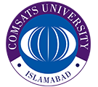
COMSATS
University Islamabad, Lahore Campus

Department of Computer Sciences

Terminal Lab Exam – SEMESTER Spring – 2025 – Student Sheet
Course Title: | Software Testing (LAB) |  |  |  | Course Code: |  | CSE 455 |  |  | Credit Hours: | 3(2,1)
Course Instructor | Yella Mehroze |  |  |  | Programme |  | BSE
Semester: | 8th | Batch: | FA21-BSE | Section: | A |  | Date |  | June 18th , 2025
Time Allowed: | 1 hr 30 mints (+ 1 hr 30 mints Viva) |  |  |  |  | Maximum Marks: |  |  | 50
Student’s Name: | Aoun Haider |  |  |  |  | Reg. No. |  | FA21-BSE-133
Write your name & ID on the question paper. Paste the solutions in the space provided in the solution format document. Return the question paper by the end of the exam.

TOTAL MARKS [8+9+8+25=50]
Total Marks Obtained : /50

Question 1:

[CLO <4>]; Implement a program using basic programming constructs.

Bloom Taxonomy Level<Applying>
Marks Obtained : /11
PART-A [Marks 8]
Part A
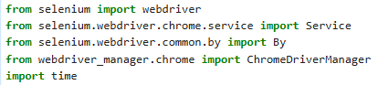

Code for each task:
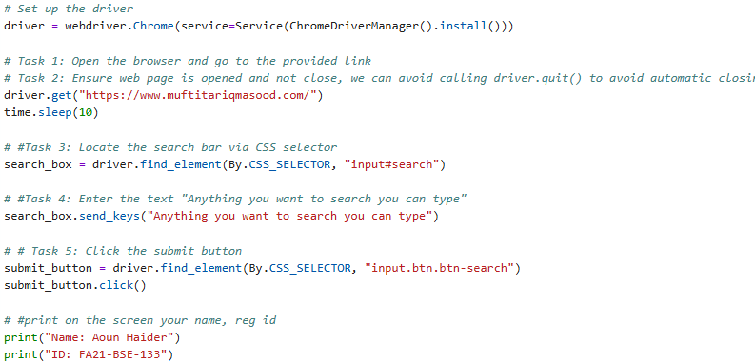

Output:
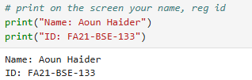

- Targeting search bar using CSS selector 'input#search'
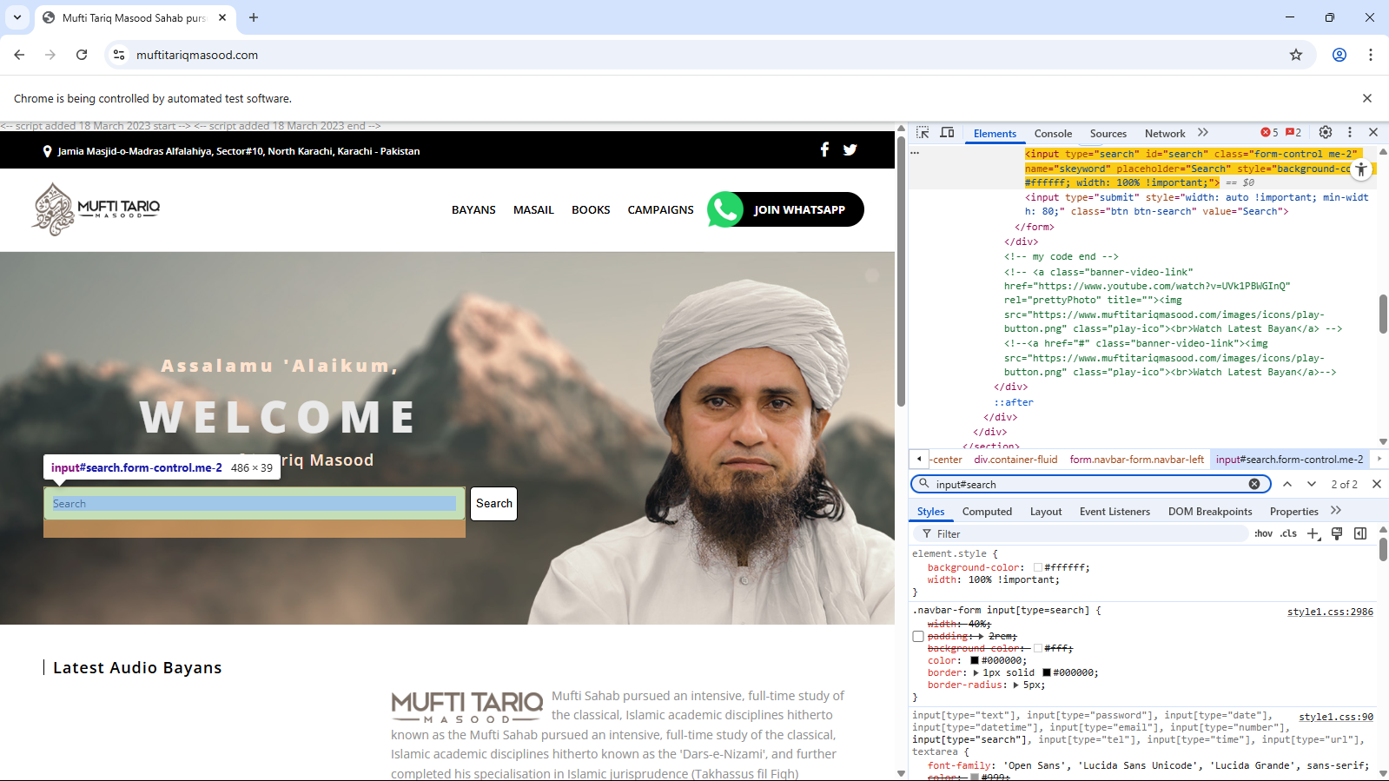

- Targeting search button using CSS selector 'input.btn.btn-search'
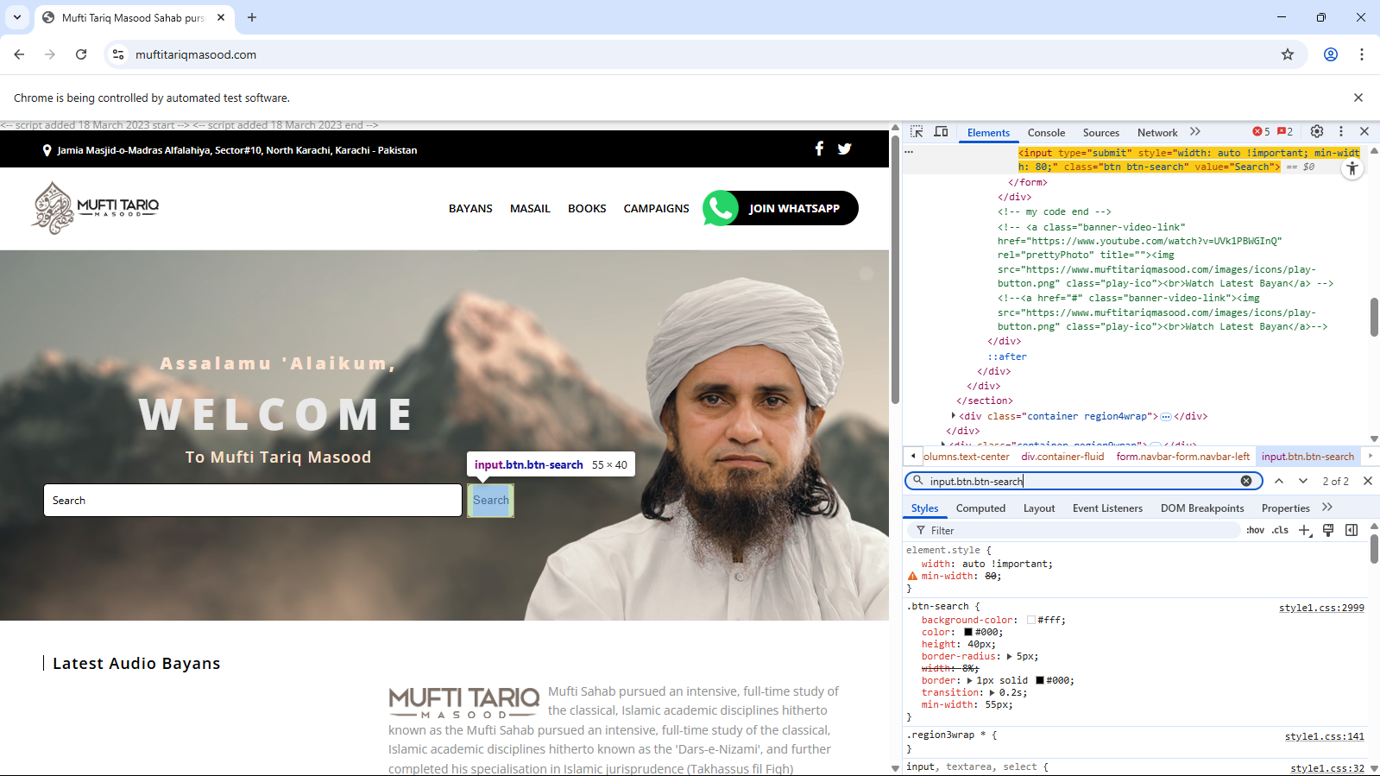

Marks Obtained : /9
PART-B [Marks 4+5=9]
- /DrIsrarCollection/collection[@type="Monarchy"]/title
- /DrIsrarCollection/collection[1]

Marks Obtained : /8
PART-C [Marks 8]
Query: ' UNION SELECT null, version() -- -
Checking the version of database:
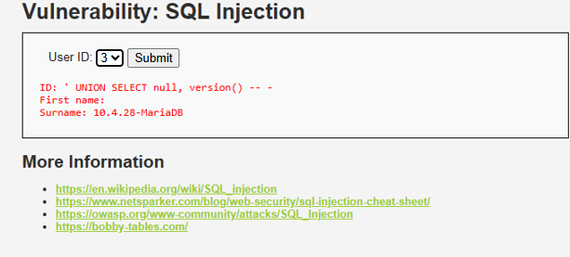

Getting usernames from database:
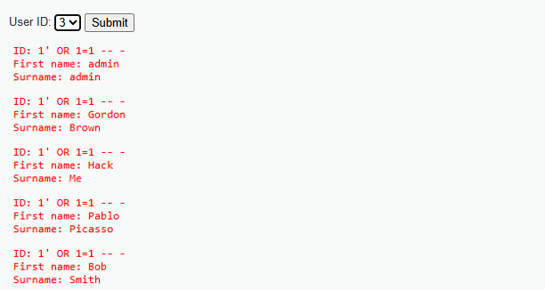

PART-D [Marks 25]
Marks Obtained : /25
Project Viva Voce
It will be conducted just after you submit the Lab Exam in the classroom. Students are advised to open their projects on the system well before their turn and wait silently for their viva turn.

